SearchAtlas Review: The All-in-One SEO Toolkit for Digital Marketers

Introduction
SearchAtlas is an AI-powered SEO platform designed to help businesses, marketers, and agencies optimize their websites for better search engine visibility. With a comprehensive suite of tools covering keyword research, content optimization, backlink analysis, and rank tracking, SearchAtlas aims to provide a competitive edge in the ever-evolving SEO landscape. But how does it stack up against industry giants like SEMrush and Ahrefs? Let’s dive in and find out.
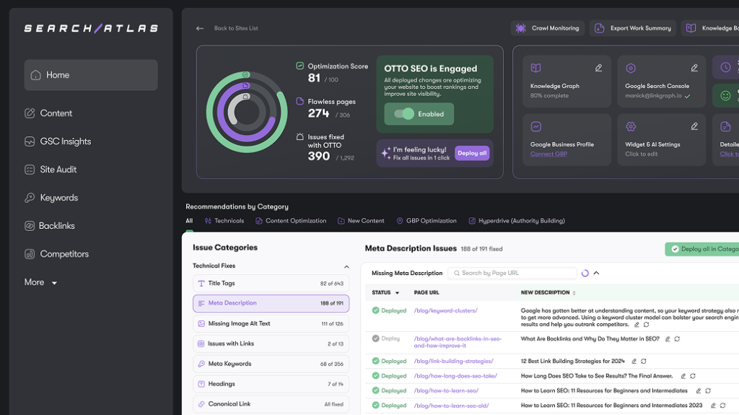

Key Features

1. Keyword Research and SERP Analysis
SearchAtlas offers a powerful keyword research tool that helps users identify high-performing keywords based on search volume, competition, and user intent. The SERP analysis feature provides insights into top-ranking pages, allowing users to optimize their content accordingly.
Pros:
- AI-driven keyword suggestions
- Competitor analysis for keyword gaps
- SERP preview for strategic content planning
Cons:
- Limited historical data compared to SEMrush
- Some keyword difficulty scores may vary

2. Content Optimization and AI Writing Assistant
One of the standout features of SearchAtlas is its AI-driven content optimization tool. This feature provides real-time SEO suggestions and readability improvements, ensuring that your content is both engaging and search engine-friendly.
Pros:
- AI-powered content suggestions
- SEO scoring to improve rankings
- Integration with Google Docs and WordPress
Cons:
- AI-generated suggestions sometimes lack contextual accuracy
- Can be overwhelming for beginners

3. Backlink Analysis and Link Building
Backlinks remain a crucial ranking factor, and SearchAtlas provides in-depth backlink analysis. The tool helps users track existing backlinks, discover new link-building opportunities, and analyze competitors’ backlink profiles.
Pros:
- Comprehensive backlink tracking
- Competitor backlink insights
- Broken link detection for easy fixes
Cons:
- Backlink database smaller than Ahrefs
- Limited outreach features

4. Site Audit and Technical SEO
The Site Audit feature scans websites for technical SEO issues, such as broken links, slow-loading pages, and duplicate content. Users receive detailed reports with actionable recommendations to improve site performance.
Pros:
- Automated SEO health checks
- Mobile and desktop performance analysis
- XML sitemap and robots.txt suggestions
Cons:
- Some technical insights require manual fixes
- Crawl speed can be slower for large sites

5. Rank Tracking and Performance Monitoring
SearchAtlas provides accurate rank tracking for keywords across multiple locations and devices. The real-time ranking updates help users adjust their SEO strategies accordingly.
Pros:
- Daily rank updates
- Competitor ranking comparisons
- Mobile vs. desktop rank tracking
Cons:
- Historical ranking data is limited
- No integration with Google Search Console for rank validation

Pricing
SearchAtlas offers multiple pricing plans tailored for individuals, businesses, and agencies. While it provides a free trial, premium plans unlock more advanced features.
- Starter Plan: Ideal for freelancers and small teams
- Growth Plan: For agencies and mid-size businesses
- Pro Plan: Agencies ready to scale and Enterprise
- Enterprise Plan: Custom functionality & tailored quotas
Compared to SEMrush and Ahrefs, SearchAtlas is more affordable, making it a budget-friendly choice for startups and small businesses.
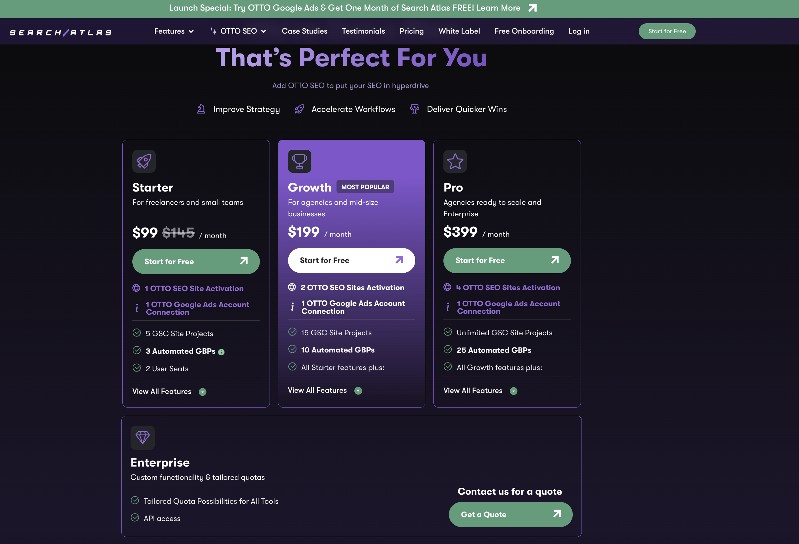

Who Should Use SearchAtlas?
- Freelancers & Bloggers: For keyword research and content optimization
- Small Business Owners: To improve online visibility and local SEO
- SEO Professionals: For in-depth backlink analysis and rank tracking
- Marketing Agencies: To manage multiple client websites efficiently

Final Verdict: Is SearchAtlas Worth It?
SearchAtlas is a solid SEO tool with a broad range of features, making it an excellent choice for businesses looking to enhance their search engine performance. While it may not yet surpass industry leaders like Ahrefs and SEMrush in terms of database size and historical data, its affordability and AI-powered tools make it a compelling option for many users.

Pros:
✔ AI-driven SEO insights ✔ Affordable pricing ✔ Comprehensive site audit features ✔ Solid keyword research and content optimization tools

Cons:
✖ Smaller backlink database compared to competitors ✖ Limited historical data for keyword ranking ✖ Some AI suggestions need manual refinement
Overall Rating: 4.3/5 ⭐⭐⭐⭐☆
If you’re looking for a cost-effective SEO solution with AI-powered features, SearchAtlas is worth trying. Whether you're an entrepreneur, a digital marketer, or an agency, this tool provides valuable insights to boost your online presence.

